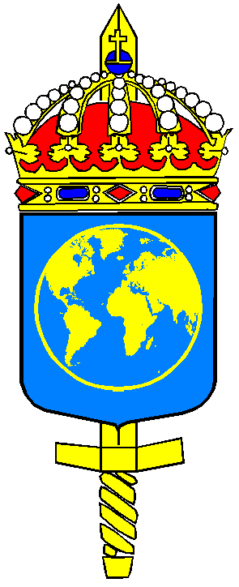
REGISTRATION FORM
Community of Interest Workshop March 20-21, 2018

Please complete this Registration Form in English and return it NLT March 05 2018.

Life Guards
NCGM Fax: +46 (0)8 584 526 20
SE-196 85 Kungsängen E-mail: swedint@mil.se
Sweden

Please supply us with one registration form and short bio (200 words limit) per participant.
Submit the bio to swedint@mil.se

PERSONAL DATA Male Female
First name: | Family name:
Date of birth: | Nationality:
Organisation:
Rank: | Date of rank:
Passport number: | Valid until:
Swedish Personal ID Number (if applicable):

Residence:

Phone number, home: *) | Phone number, work: *)
Cellular Phone number: *) | Facsimile: *)
E-mail:

*) In case of emergency
Special Dietary or food requirements due to medical or religious reasons: Yes No | If yes, please specify articles or food you cannot eat:
Date and approximately time of Arrival: | Date of Departure:
Joint transport to Arlanda Airport will be arranged from the Regiment on March 21 at the close of seminar
(approx. 16:30 hrs). Do you wish to use joint transport? Yes No

Requested accommodation at Life Guard Regiment student hotel for the dates:

