International Military Sports Council

Swedish Delegation

INVITATION FILE

67th World Military Pentathlon Championship

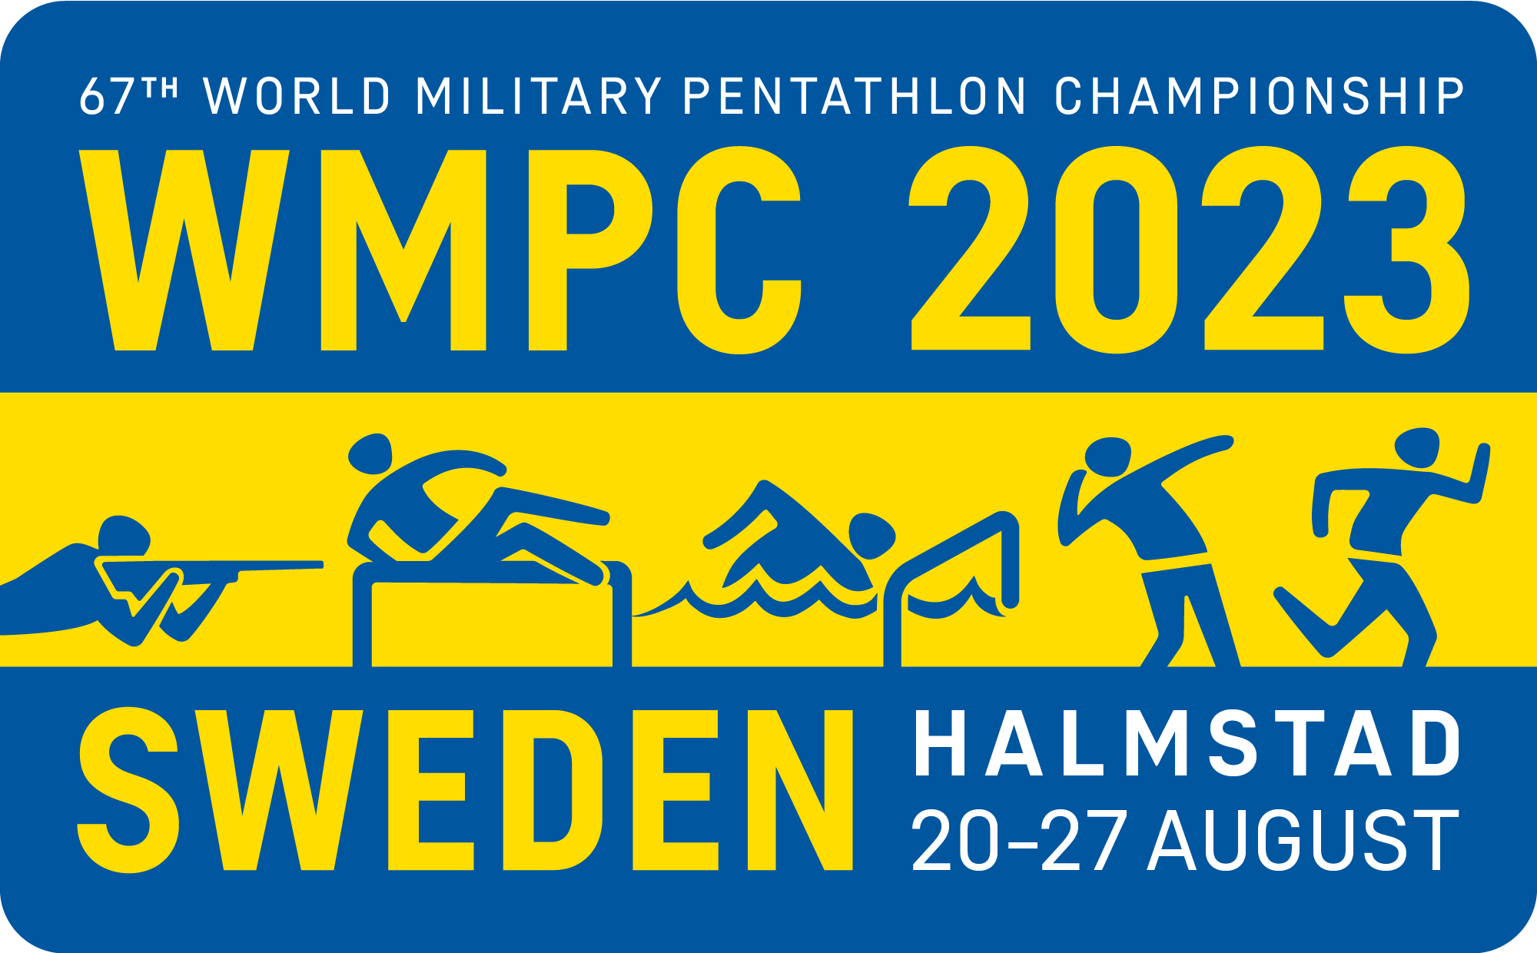

20-27 August 2023, Swedish Air Defence Regiment, Halmstad, Sweden

CISM

“Friendship through Sport”

Chief of Delegation to CISM SWEDEN
Lt Col Jokim Hahn
MHS K/FMIF
SE-107 86 STOCKHOLM - SWEDEN
Phone: + 46 8 514 39 901
Fax: + 46 8 514 39 900
Mail: sven.antonsson@mil.se

To: See Distribution List.
Subject: 67th World Military PENTATHLON Championship 2023
Date: 20-27/8/2023

The Swedish Armed Forces will host the

67th World Military pentathlon championship 2023

Sweden has the great honor of inviting a mission representing the Armed Forces of Your country to participate in the 67th World Military Pentathlon Championship, which will be held in the Garrison of Halmstad from 20th to 27th of August 2023. The organizing committee will put great energy to create the best possible conditions for participants and we wish You a warm welcome to the Garrison of Halmstad.

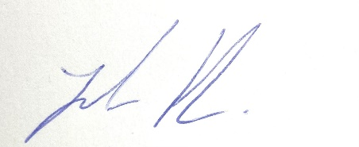
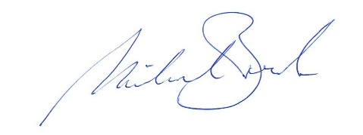
Colonel Mikael Beck Lt Col Joakim Hahn
President Organizing Committee Chief of Swedish Delegation to CISM
Chief of Swedish Air Defence Regiment

ENCLOSED:

- Distribution List;
- Program;
- General Information;
- Annex 1 – Preliminary Agreement;
- Annex 2a – Final Entry – Composition of the Mission;
- Annex 2b – Final Entry – Competitors;
- Annex 2c – Final Entry – Commitment by the Chief of Mission;
- Annex 3 – Final Entry – Travel data.

Distribution List

All CISM member nations are warmly invited and strongly encouraged to participate in this World Championship.

President of CISM.

Official CISM Representative.

The Vice-President of Europe.

CISM Secretary General.

Chief of European Liaison Office.

President and Members of CISM Sport Committee.

Representatives of the CISM Partners and Sponsors.
- To the Chiefs of Delegation of CISM Members Countries:

- Right to participate in the 67th World Military Pentathlon Championship
Only CISM active member nations have the right to participate in the 67th World Military pentathlon championship.
An inactive nation, intending to take part in the event must pay its annual fee before the deadline established by the Organizing Committee of the World Military championship for sending the final entry. If this is not done, the delegation will not be able to take part in the event.

General Program of the Championship

DATE | ACTIVITY
Sunday 20th | - Arrival of the Participants
Monday 21th | - Training  - Preliminary meeting  - Opening ceremony
Tuesday 22th | - Shooting
Wednesday 23th | - Obstacle Run  - CSC Enlarged meeting
Thursday 24th | - Obstacle swimming  - Throwing
Friday 25th | - Cross-country  - Training obstacle relay  - CSC restricted meeting long
Saturday 26th | - Obstacle relay  - Closing ceremony  - Banquet
Sunday 27th | - Departure of missions

Composition of the Mission
A mission for obligatory disciplines will include a total of 14 persons divided as follows:
- 1 Chief of mission
- 1 Team captain
- 2 Coaches (male, female)
- 1 medical staff/physiotherapist
- 4 female competitors
- 5 male competitors
- CSC members are not counted in maximum number of persons

According to the CISM Regulations Edition 2021, competitors must be military personnel on active duty within the Armed Forces of their respective country with an up to date military identity card (CISM Regulations, Art. 7.23, item A).

Access to the Location of the Competition
The Championships are hosted by the Swedish Armed Forces. The Swedish Air Defence regiment, located at the Swedish west coast 130 km south of Gothenburg, is responsible for the practical arrangements.
Participating missions are responsible for their own travel expenses to and from Sweden and are requested to arrive at Halmstad railway station, Halmstad city airport (domestic flight), Landvetter airport/Gothenburg or Sturup airport/Malmö. Arrivals by bus or car are possible directly to the Garrison. The organizer is responsible for local transportation in Sweden.

Conditions of Stay
During their stay in Sweden, the missions will be the guests of the Swedish Armed Forces from 20th to 27th of August 2023. Organizer cannot host earlier arrivals or late departures. Normal board and lodging is at the expense of the organizer. Observers from coming organizers are welcome after request. Special requirements and additional drinks are to be paid by the participants.

Menus are varied, special diets and religion related requirements can be arranged on demand. Please, indicate these in the Final Entry form.

Team captain, coaches, physiotherapists and competitors will be accommodated in barracks of the garrison area. Chief of Mission and CISM representatives will be accommodated in apartments at the garrison area or Hotel in Halmstad city.

The organizers will take care of medical support (first aid) on site. Further costs incurred for medical support are to be borne by the participants. To cover risk, the participants must arrange sufficient insurance in their home countries.

The organizer is not responsible for:
- Hospitalizations and dental,
- Surgical operations or special treatments,
- Repatriation in case of decease by illness or accident,
- Other expenses on account of illness/accident such as compensations, loss of income, etc.

In Sweden, tap water is fully fit for drinking. The use of bottled water is not necessary.

Regulations of the Championship
The competitions will be governed by CISM regulations:
- CISM Regulations Edition 2021.
- CISM Military Pentathlon Regulations edition 2020.
- CISM Anti-doping Regulations 2020.

Competition arenas
- Obstacle swimming located 5 km from Halmstad Garrison. Outdoor arena with 2 competition lanes, 50 meter.
- Shooting arena, 200 meters range with 20 lanes. Shooting direction South-West.
- Obstacle run course, built in 2020 with asphalt surface and 4 curves.
- Throwing arena, 6 competition ranges and 3 practise ranges. Throwing direction north.
- Cross country, 4 km course on gravel and hard packed soil with a total elevation of approximately 25 m.

All the competition arenas except obstacle swimming are located inside Halmstad Garrison on walking distance from the barracks.

Anti-doping

Anti-Doping tests will be conducted in accordance with the CISM Regulations – Chapter IX, the CISM Anti-Doping Rules, CISM Military Pentathlon Regulations
CISM Anti-Doping Symbol

The number and type of tests and which athletes to be tested shall be determined by the CISM Anti-Doping Commission.

In case an athlete has a Therapeutic Use Exemption (TUE), the athlete’s Delegation should send this TUE to the CISM General Secretariat, with a copy to the Organizing Committee, until 30 days before the Opening Ceremony in order to get an approval to this athlete participate of the event.

The test are to be conducted by: https://antidoping.se

The tests will be sent to the following laboratory for analyzing:
https://www.karolinska.se/for-vardgivare/karolinska-universitetslaboratoriet/klinisk-farmakologi/dopinglaboratoriet/the-swedish-doping-control-laboratory/

Uniforms
Uniforms are mandatory. The participating missions are permitted and obliged to be in uniform (summer dress) during the stay on the scheduled occasions like the opening and closing ceremony.

Customs and Visa Procedures

Information concerning request for visit and procedures for customs and visa is normally obtained by the participating nations´ embassies respectively in Sweden. The Swedish embassies in the participating nations can present information as well concerning these issues.
Request For Visit (RFV) download at: https://www.mil.se/wmpc23

Regarding temporary import for weapons and ammunition to Sweden, nations within EU or NATO has to fill in EU/Nato customs form 302 according to national instructions. For non EU/Nato nations – a complete Final entry form will be sufficient.

Weather Conditions

Average weather conditions in August in Halmstad:
- Temperature: +15 to +25 C

General information

All official information will be provided at the Championship Website: https://www.mil.se/wmpc23
Each person must bring:
- Passport, visa, and be aware of the Swedish customs regulations
- Military identity card
- Service uniform is required for official events
- 2 Padlocks
- Ammunition and rifle

Each participating nation should bring 1 flag (120x200cm) and the chief of delegation is responsible to check that their national anthem is available on CISM Extranet.

Each country is responsible for uploading a digital passport photo on www.military-pentathlon.info. This includes all attending personnel.

The organizers will not provide rifles or ammunition.

Registration Forms Deadlines

Registration forms to send back to
Preliminary Agreement (Annex 1): Before 19th of May 2023.

Final Entry (Annex 2 a, b and c): Before 19th of July 2023.

Final Entry Travel data (Annex 3) Before 4th of August 2023.

Request For Visit, Before 19th of July 2023.
Download at https://www.mil.se/wmpc23
Shall have been addressed to Swedish Armed Forces Headquarters INSS J3 via
Participating nation’s embassies in Sweden.

Correspondence

67th World Military Pentathlon Championship
Swedish Air Defence Regiment
P.O. Box 515
SE-301 80 Halmstad – SWEDEN
Tel: +46702075123
Fax: +46 35 266 30 09
E-mail: lv6-milpent@mil.se

ANNEX 1

Preliminary Agreement
To be returned before 19th/may/2023:
Swedish Air Defence Regiment
P.O. Box 515
SE-301 80 Halmstad - SWEDEN
Fax: +4635 266 30 09
E-mail: lv6-milpent@mil.se

Delegation to CISM:  Chief of Delegation to CISM SWEDEN  Lt Col Jokim Hahn  MHS K/FMIF  SE-107 86 STOCKHOLM - SWEDEN  Phone: + 46 8 514 39 901  Fax: + 46 8 514 39 900 | CISM Headquarters:  CISM HQ  Lt Col Jan Van den Dool  CISM Sports Director  Mobile: +31 630861878  E-mail: cismsportsdepartment@milsport.one

NATION:

TOTAL NUMBER of PARTICIPANTS:
 | Officials | Athletes | CSC members | Referees | Total
Men
Women
Total

Means of transPORT: _____________________________________________

DATE:____________ | ______________________________________________
 | SIGNATURE OF CHIEF OF DELEGATION
 | RANK/NAME:____________________________________

Your Contact | Rank/Name
 | Phone
 | Fax
 | E-Mail
ANNEX 2a

FINAL ENTRY - COMPOSITION OF THE MISSION
To be returned before 19th/July/2023:
Swedish Air Defence Regiment
P.O. Box 515
SE-301 80 Halmstad - SWEDEN
Fax: +4635 266 30 09
E-mail: lv6-milpent@mil.se

Delegation to CISM:  Chief of Delegation to CISM SWEDEN  Lt Col Jokim Hahn  MHS K/FMIF  SE-107 86 STOCKHOLM - SWEDEN  Phone: + 46 8 514 39 901  Fax: + 46 8 514 39 900 | CISM Headquarters:  CISM HQ  LtCol Jan Van den Dool  CISM Sports Director  Mobile: +31 630861878  E-mail: cismsportsdepartment@milsport.one

NATION :

# | Function | Rank | Name and Surname
 | Chief of Mission
 | Team Captain
 | Coach
 | Coach
 | Physiotherapist/medical
 | Male athlete
 | Female athlete
 | CSC Member
In strict compliance with applicable CISM Regulations – Chapter VII, Art. 7.23, I the undersigned Chief of Delegation, hereby officially confirm that all athletes representing my nation in the CISM event are on active duty in my nation’s Armed Forces. I understand that sanctions may be imposed against my nation, my mission, my team, individual athletes, or myself for violation of this provision (CISM Regulations Chapter I, Art. 1.12).

DATE:________ | __________________________________________________
 | SIGNATURE OF CHIEF OF DELEGATION
 | RANK/NAME:_______________________________________

ANNEX 2b

FINAL ENTRY COMPETITORS
Rank | Gender | Surname | First name | T-shirt size (unisex) XS-2 XL | Date of birth  YYYY-MM-DD | Special diets | Weapon  Serial.nr | Type of  weapons | Qualifying  competition  B-nation | Points
 | Female
 | Female
 | Female
 | Female
 | Male
 | Male
 | Male
 | Male
 | Male

ANNEX 2c

FInal Entry - COMMITMENT BY THE CHIEF OF MISSION

NATION :

The undersigned, Chief of Mission declare that he has read the CISM Regulations and moreover understood the following prescriptions:

Article 1.10. RIGHTS OF MEMBER NATIONS
- Active member nations have the right to:
Be invited to all CISM Championships.
- Inactive member nations have the same rights as active member nations except that:
They do not participate in any CISM event until they have met their financial obligations.
An inactive nation, intending to take part in the event must pay its annual fee before the deadline established by the Organizing Committee of the world military championship for sending the final entry. If it is not done, the delegation will not be able to take part in the event.

Article 7.23. PARTICIPATION - MILITARY STATUS
A. Only military personnel on active duty in Armed Forces may take part in competitions organized by CISM.
B. No one may be recalled to active duty in the Armed Forces for the purpose of participating in a CISM competition. In the case of an intermittent military service, the athletes regularly recalled may not take part in CISM competitions, under any circumstances, if more than 18 months have elapsed between this recall and the end of their last call to arms.
C. Exceptions to the above may be authorized by the General Assembly, upon recommendation of the Board of Directors.
D. All military participants in a CISM event shall be in possession of proper documentation which signifies active military service of the member nation he represents. The documentation can be:
1. A valid military identity card for those athletes who are authorized to present their military identity cards abroad,
2. A form of verification (in English and/or French) of military status accompanied by a passport.
E. By signing the final entry, the Chief of Delegation confirms the military status of the participating athletes. If there are last minute changes in the participation of the athletes, the verification file may be signed by the Chief of Mission, but shall be confirmed by the Chief of Delegation by official letter.
F. If one of these documents is not available, participation is refused.

Article 7.32. CHIEF OF MISSION
- Chief of Mission
- Chiefs of Mission shall be familiar with CISM regulations.
- Missions must not only participate or be present at sports events, they are also required to participate in information conferences on CISM, study days, commemorative and cultural events and ceremonies organized by the host nation.

- Conduct of a mission
- The Chief of Mission is responsible for the behavior of his team in sports and general discipline. He shall ensure that members of his mission respect the rules and directives prescribed by CISM and organizers of the championship. The respect of schedules is particularly important as they form the basis for the effective conduct of competitions and ceremonies.
- The Chief of Mission shall also enforce the rules concerning behavior and dress during the ceremonies. He plays an important role in promoting the CISM spirit among his mission, a spirit represented by friendly attitude towards other missions, courtesy towards organizers and fair-play in competition.

Article 8.6. ABSENCE OF A MISSION WITHOUT NOTIFICATION
If a mission which submits a preliminary agreement and/or final entry is absent without notifying the host nation in time, a sanction will be imposed (CISM Regulations, 2021, Art. 1.12).

Article 8.17. RULES OF STAY
A. General
1. The Chiefs of Mission are responsible for the discipline of their mission. The missions fall under the jurisdiction of the organizing nation. During events, all athletes present on the playing fields are equal before the jury, the referees and to themselves. No one may use his rank to impose his views on sports matters.
2. Civilian members of the missions shall conform to the discipline accepted by all other participants.
B. Military uniforms
1. Unless otherwise approved by the Official CISM Representative, all participants shall wear military uniform during official ceremonies such as the opening and closing ceremonies and medal-awarding ceremonies. Individuals without proper uniform will not be allowed to participate in the championship.
2. The presentation of medals takes place, in principle, during the closing ceremony. The presentation of medals may be done in sports uniform, if for organizational reasons it is not possible to wear military uniforms. This is the case e.g. when the presentation immediately follows a championship sports event. Sports uniforms shall respect the corresponding national criteria (training suit, sports shoes, etc.) Displaying the national flag on the podium by the recipient (athlete or team) at a medal awarding ceremony is forbidden. Individuals failing to respect these prescriptions shall not receive their medal(s) during the official ceremonies.
C. Forbidden actions
1. In conformity with the statutes and traditions of CISM, any political or religious propaganda during a CISM event, in particular the dissemination of documents, pictures, brochures, reviews, etc. is strictly forbidden.
2. Any contravention shall result in the exclusion of the mission from further competition and may result in additional sanctions (Regulations Art. 1.12).

Article 8.19. ACCOMODATIONS
E. All missions, including those of the host nation, shall be accommodated under the same conditions. If the conditions are in accordance with the CISM norms and standards, the missions are expected to accept the accommodation provided by the organizing nation.
G. Any mission that does not accept the accommodations provided by the organizing nation and judged as adequate by the Official CISM Representative will not be allowed to participate in the championship.

DATE:__________ | ______________________________________
 | SIGNATURE OF CHIEF OF MISSION
 | RANK/NAME:___________________________

ANNEX 3

FINAL ENTRY – TRAVEL DATA
To be returned before 4th/August/2023:
Swedish Air Defence Regiment
P.O. Box 515
SE-301 80 Halmstad - SWEDEN
Fax: +4635 266 30 09
E-mail: lv6-milpent@mil.se

Delegation to CISM:  Chief of Delegation to CISM SWEDEN  Lt Col Jokim Hahn  MHS K/FMIF  SE-107 86 STOCKHOLM - SWEDEN  Phone: + 46 8 514 39 901  Fax: + 46 8 514 39 900 | CISM Headquarters:  CISM HQ  LtCol Jan Van den Dool  CISM Sports Director  Mobile: +31 630861878  E-mail: cismsportsdepartment@milsport.one

NATION :

 | PLACE | DATE | FLIGHT Nr  TRAIN Nr  BUS Nr | TIME
ARRIVAL
DEPARTURE

Means of transPORT: _________________________________________

DATE:______________ | _____________________________________________
 | SIGNATURE OF CHIEF OF DELEGATION
 | RANK/NAME:__________________________________

Your Contact | Rank/Name
 | Phone
 | Fax
 | E-Mail

